**Name: 047- Sherzaman Khan**

Q1. You have a s3 bucket containing multiple csv files under logs/ prefix each has user_id, login_time, reigon, device_type

task:

1. create athena external table to query csv file from S3

2. write query to return number of logins per region

3. save query result to s3 folder athena-result

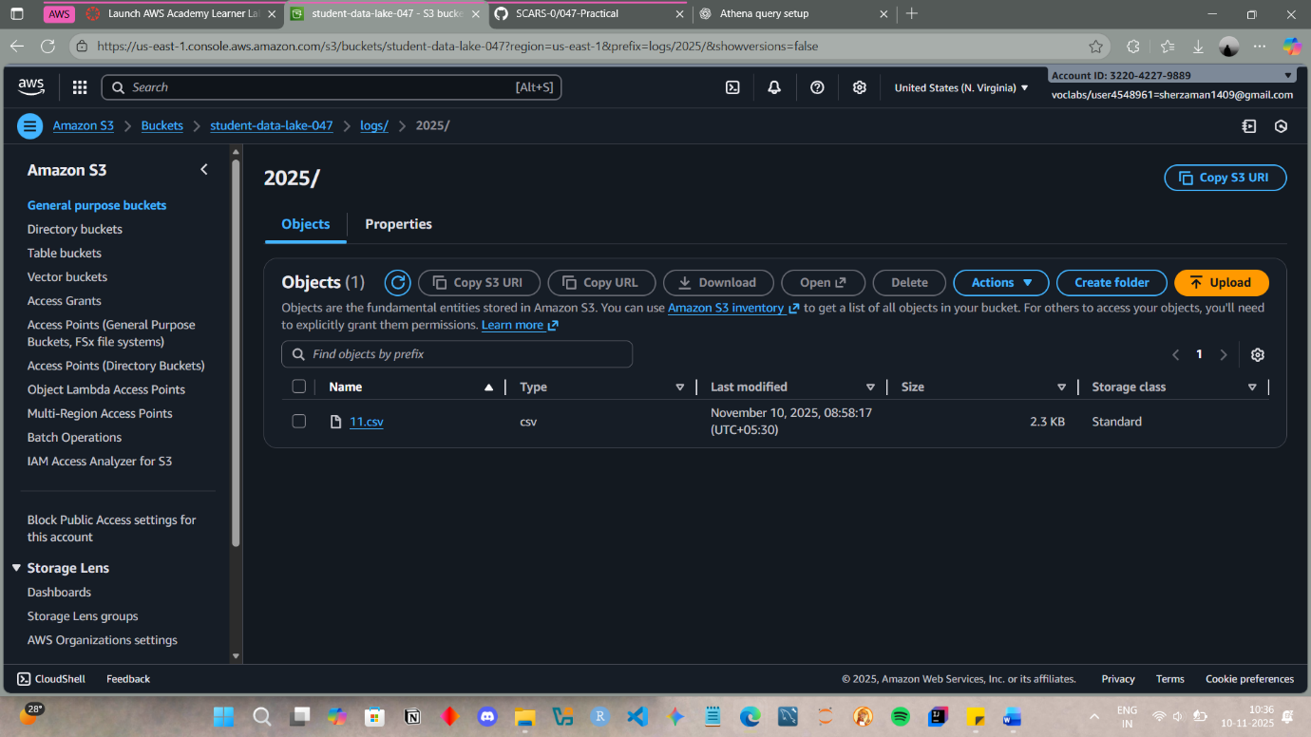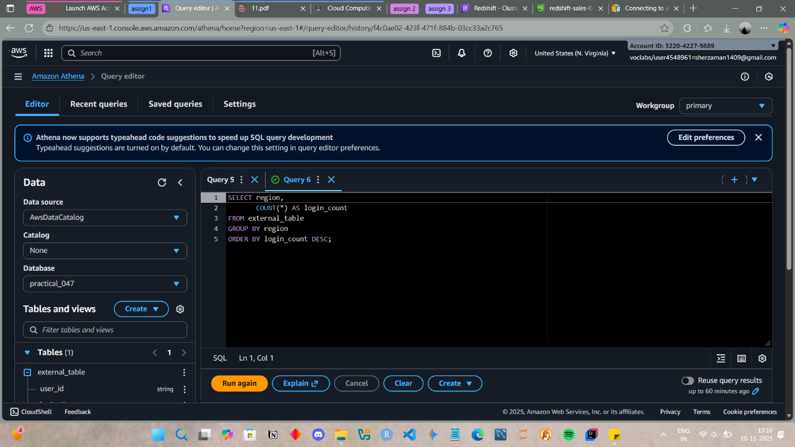

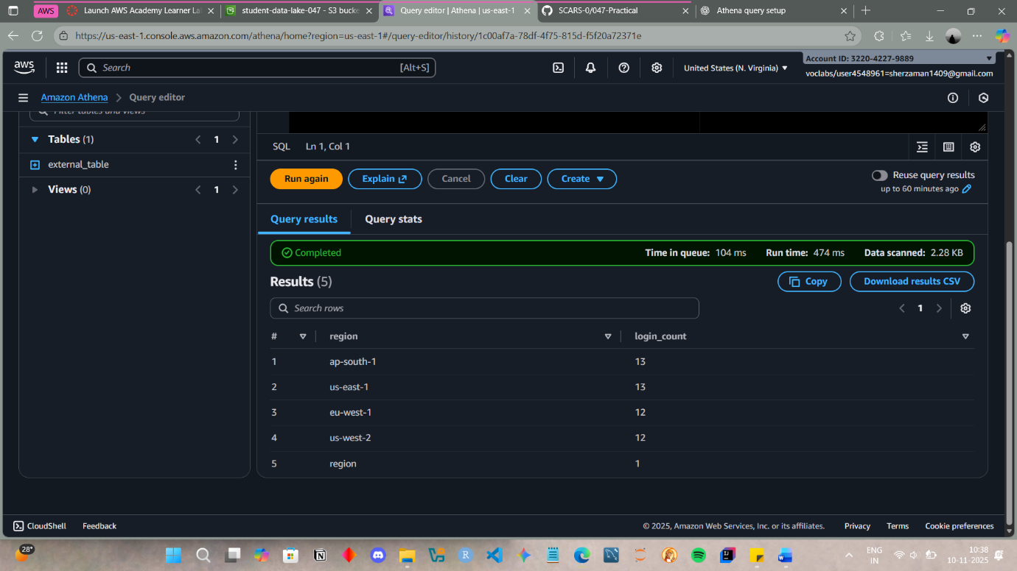

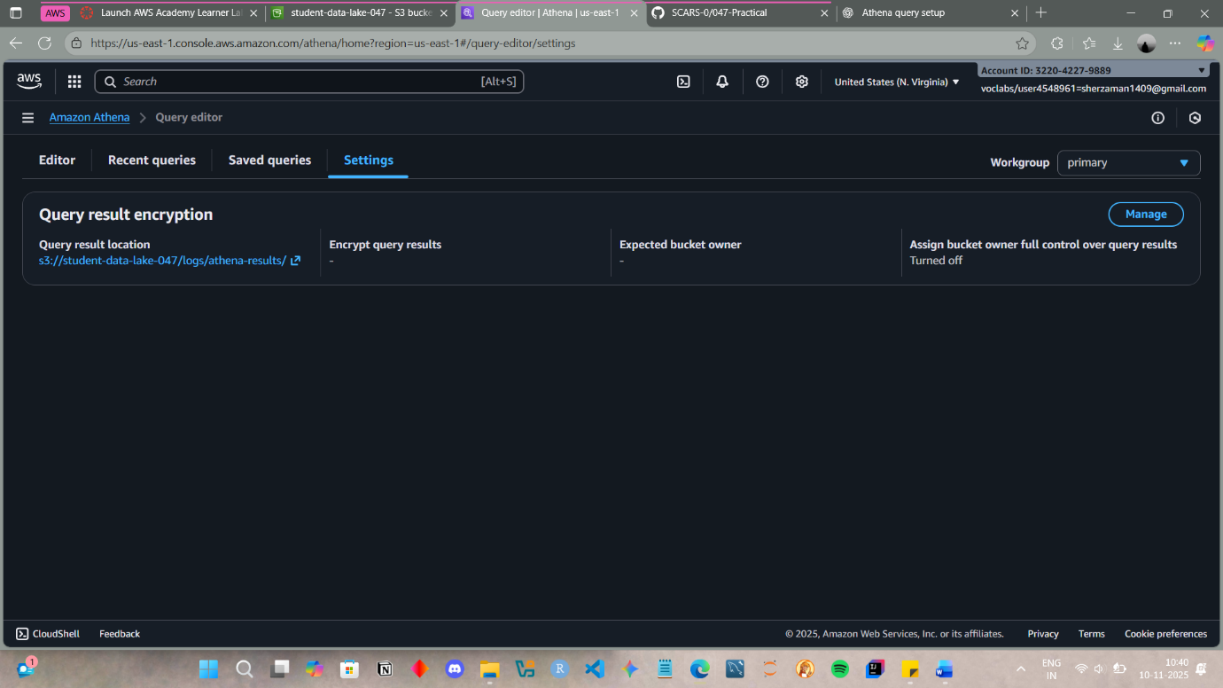

Q2. You have a s3 bucket where daily sales reports are uploaded in prefix reports/daily/ when a new file is uploaded lambda read metadeta and publishes to sns topid daily-reports-aletrs

task:

1. configure S3 lambda trigger

2. Write lambda to extract metadeta & send to SNS

3. Log errors in CloudWatch Logs

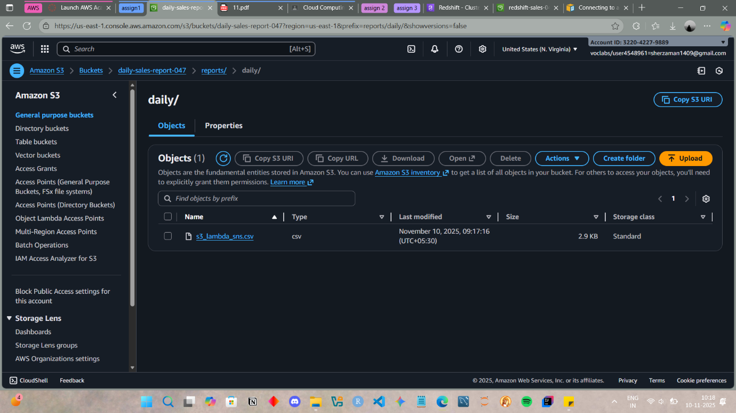

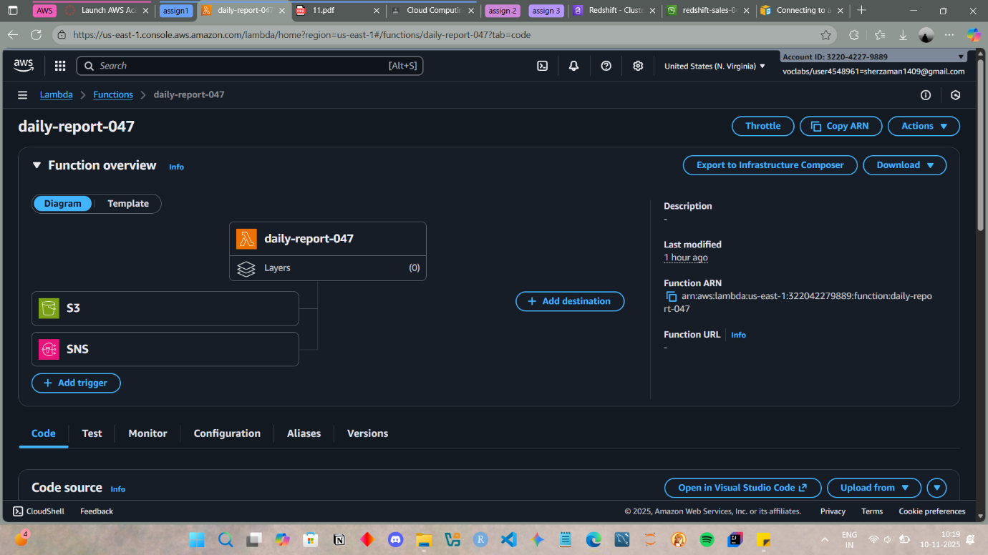

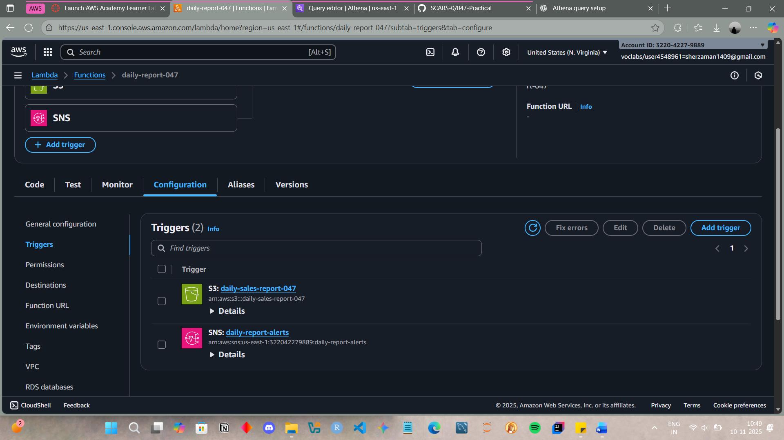

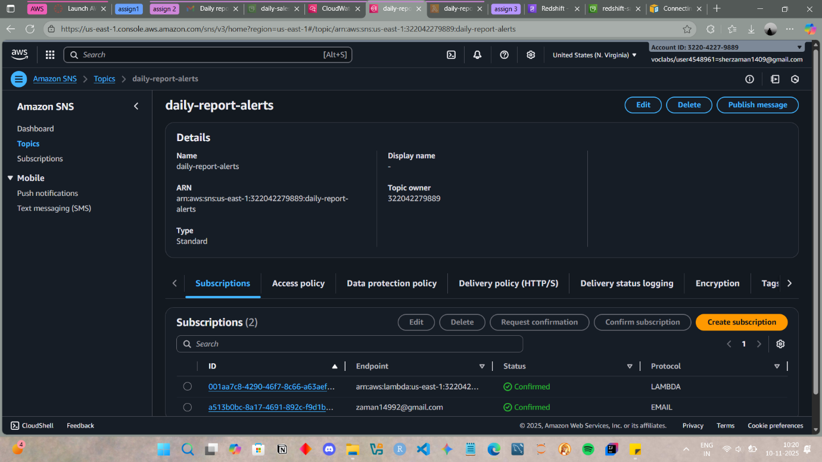

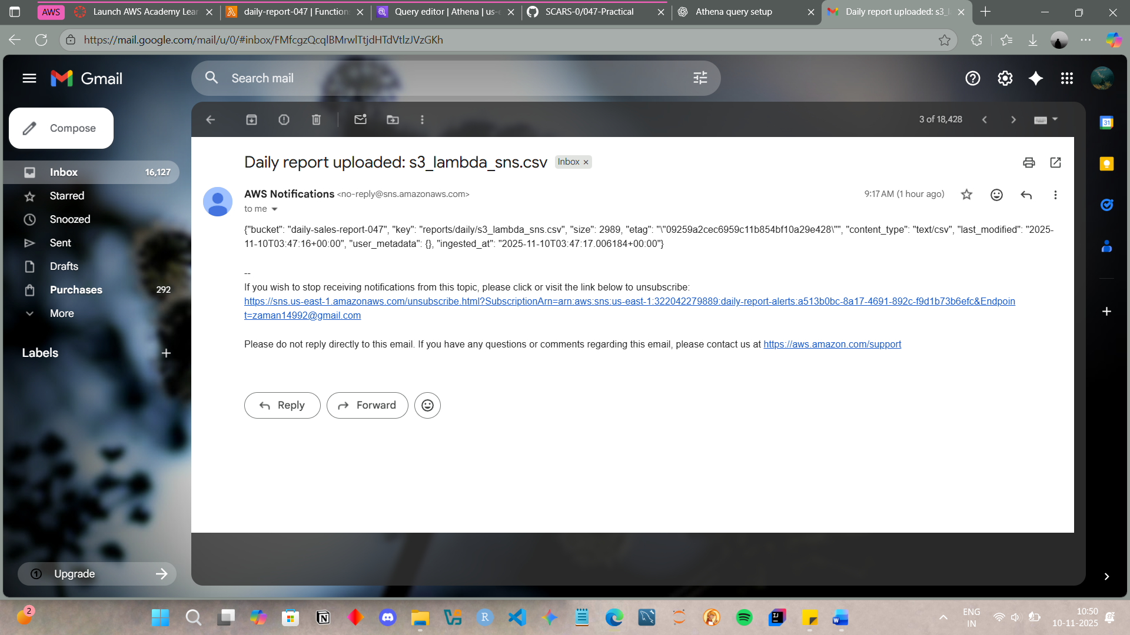

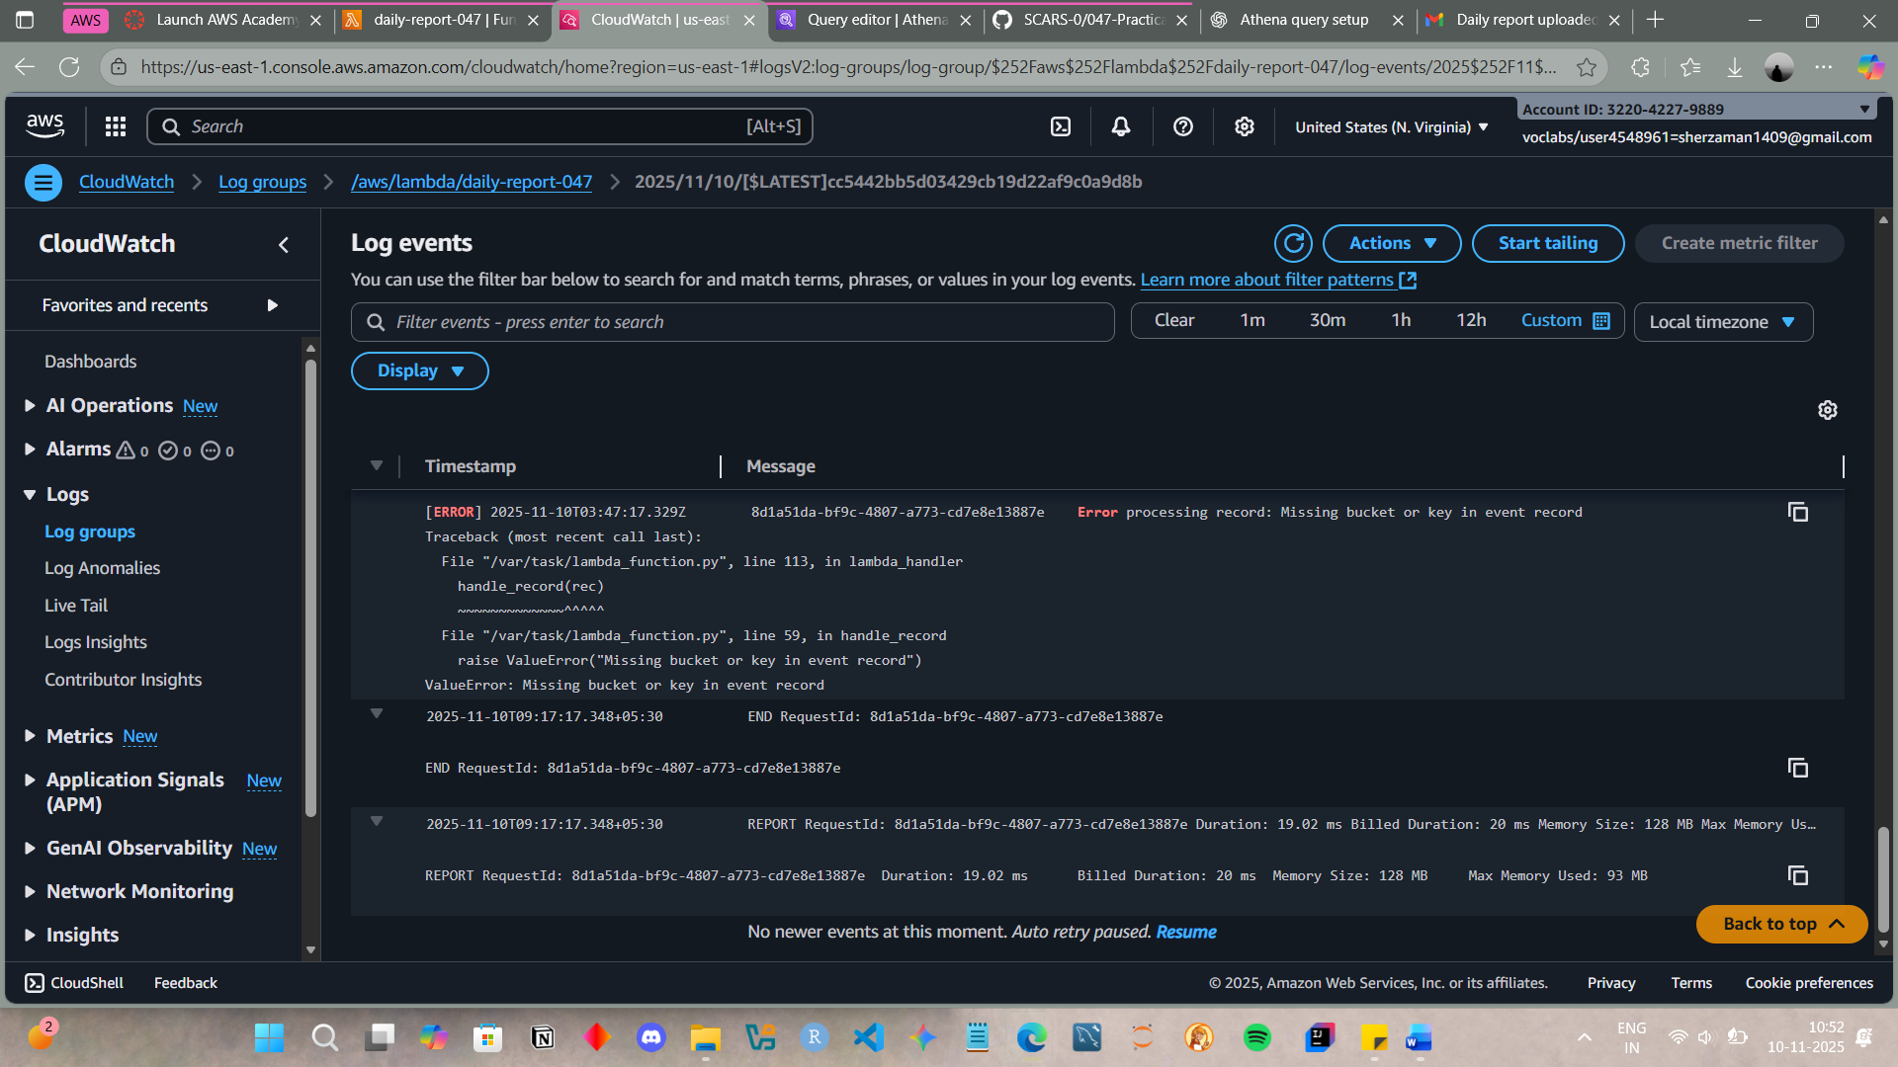

Q3. Daily csv data lands in prefix incoming/ with columns orders_id, product_id, quantity, price, order_date. Some files have missing/invalid values

Task:

1. Trigger Lambda on S3 upload

2. Lambda runs athena query via boto 3 checking missing order_id or negative price

3. If bad records > 0 send message via SNS topic daily-quality-alerts

4. Log execution metrics on Cloud Watch Logs

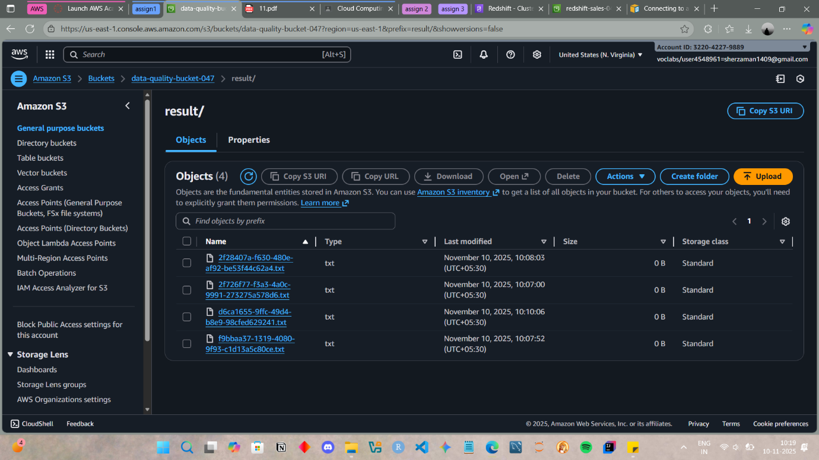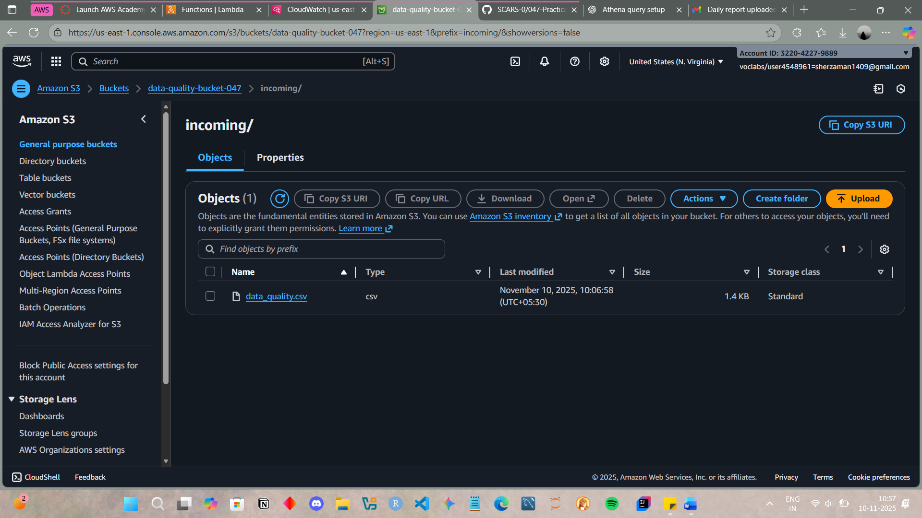

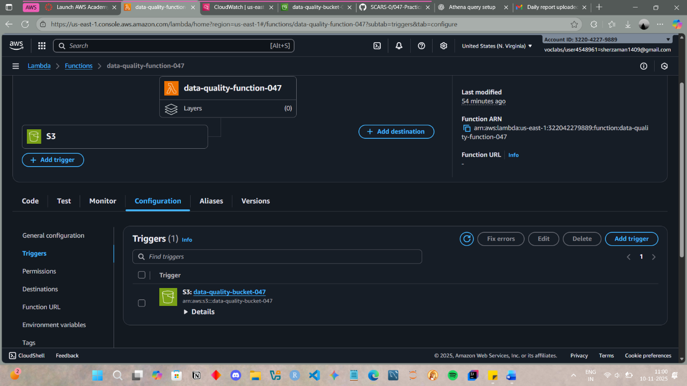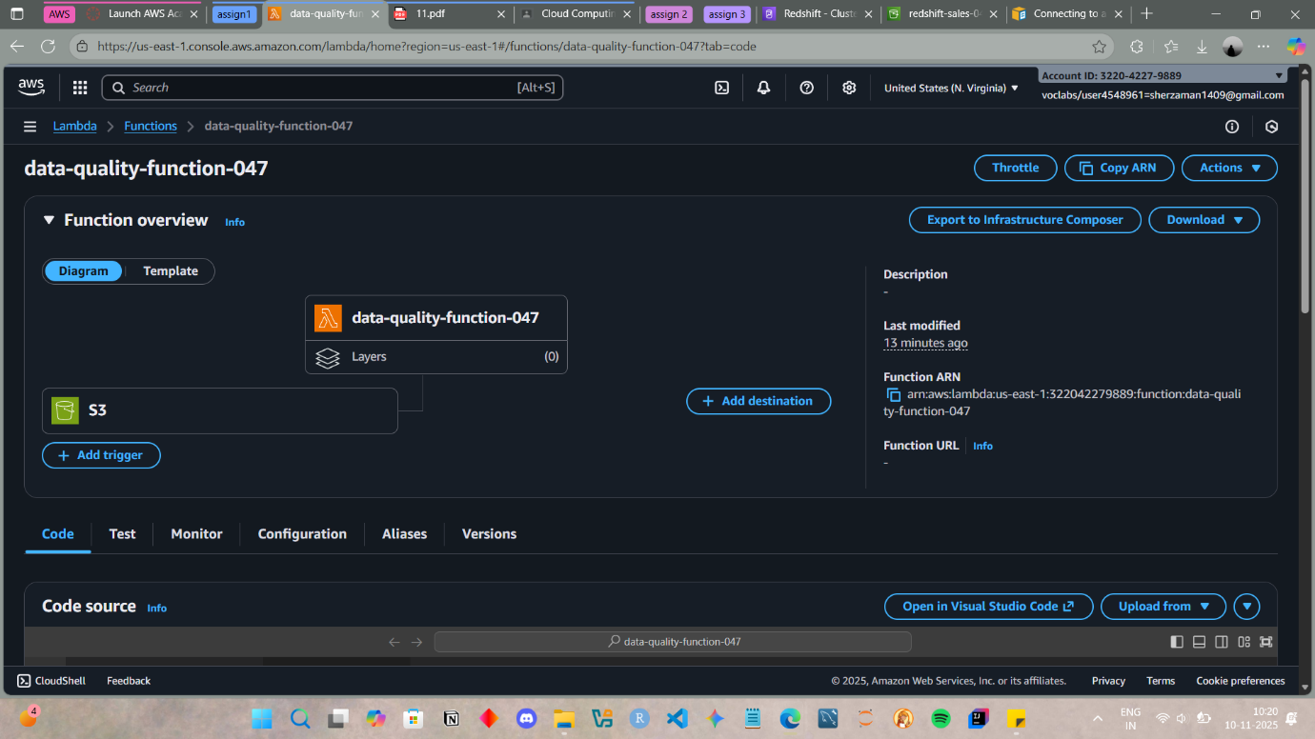

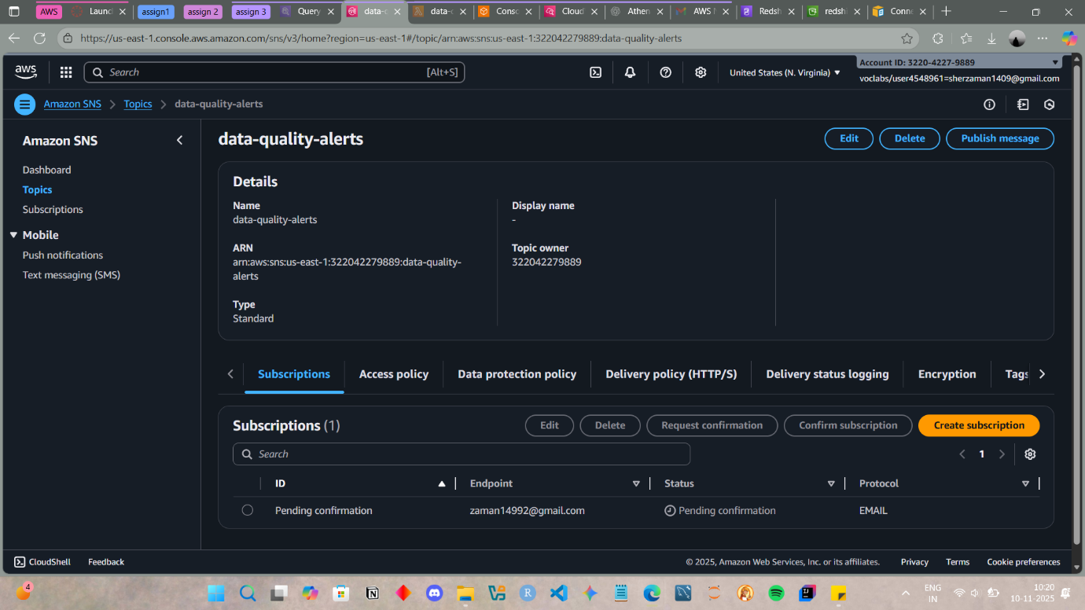

Q4.

